1. Go to the following URL --> <https://github.com/meteor/meteor/wiki/Preview-of-Meteor-on-Windows>

2. You will find below yellow marked link. Click on it and save the file. Run the exe file ( Use right click "Run As Administrator" option)

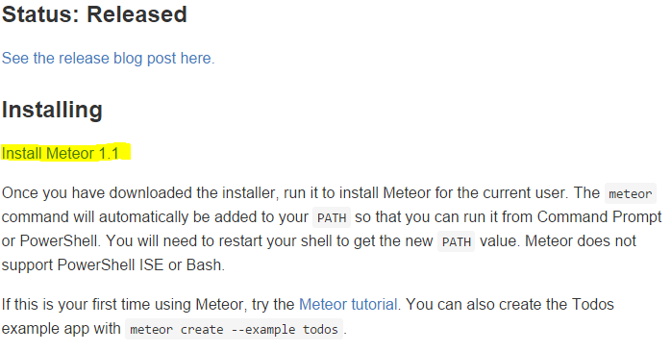

3. After the installation, check whether the following meteor command "C:\Users\Dishant\AppData\Local\.meteor\" (without quotes) is set in the PATH user variable as shown below-->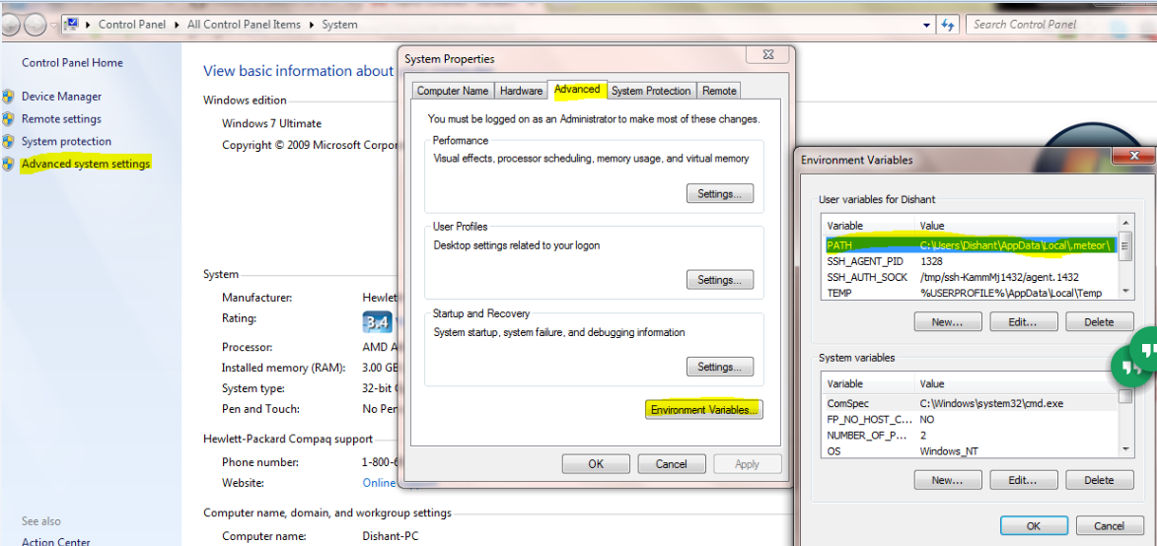

4. If it is not automatically set, then do it manually.

5. Run "meteor".command in the command prompt as shown below-->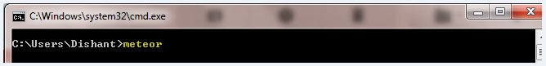

6. If it gives error or doesn't give the below output then restart the machine and again run the above command